Translation No. 2
Virgil, Aeneid 2.526 - 43

Background: Pyrrhus

Lines 2.469ff. (David West’s translation)

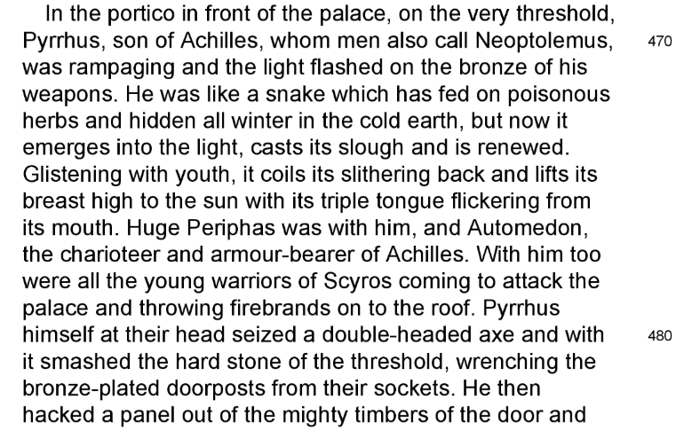

Aeneas is actually standing on the roof of his own house but acts as an omniscient narrator.

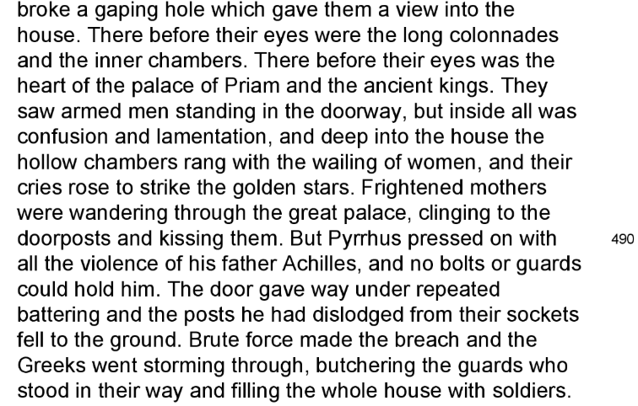

ecce autem elapsus Pyrrhi de caede Polites, 526
unus natorum Priami, per tela, per hostis
porticibus longis fugit et vacua atria lustrat
saucius. 529

“But suddenly, escaping from death at the hands of Pyrrhus, Polites, one of Priam’s sons, flees through spears, through foes, down the long colonnades and, wounded, traverses the empty courts.

illum ardens infesto vulnere Pyrrhus 529
insequitur, iam iamque manu tenet et premit hasta. 530

Pyrrhus pursues him in a blaze of anger, with intention to wound, and almost holds him in his hand and presses on him with his spear.

ut tandem ante oculos evasit et ora parentum,
concidit ac multo vitam cum sanguine fudit.

When at last he came before the eyes and faces of his parents, he fell, and poured out his life in a stream of blood.

hic Priamus, quamquam in media iam morte tenetur,
non tamen abstinuit nec voci iraeque pepercit:

Hereupon Priam, though now in death’s closest grasp (although he was now held in the grip of death), yet did not hold back nor spare his voice and wrath:

'at tibi pro scelere,' exclamat, 'pro talibus ausis 535
di, si qua est caelo pietas quae talia curet,
persolvant grates dignas et praemia reddant
debita,

‘For your crime, for such outrageous deeds as this,’ he cries, ‘may the gods - if in heaven there is any sense of righteousness which cares for such things - pay you fitting thanks and render you due rewards,

qui nati coram me cernere letum
fecisti et patrios foedasti funere vultus.

(you) who have made me see face to face my own son’s murder, and defiled a father’s face with death !

at non ille, satum quo te mentiris, Achilles 540
talis in hoste fuit Priamo;

But that man - whose son you falsely claim to be - Achilles was not such a man with his foe Priam;

sed iura fidemque
supplicis erubuit corpusque exsangue sepulcro
reddidit Hectoreum meque in mea regna remisit.'

but he had respect for a suppliant’s rights and trust; he gave back to the tomb Hector’s bloodless corpse and sent me back to my realm.’
Attic black-figure amphora with Trojan War scene. Neoptolemos kills king Priam during the sack of Troy. Date between 520 and 500 BC. Rijksmuseum van Oudheden
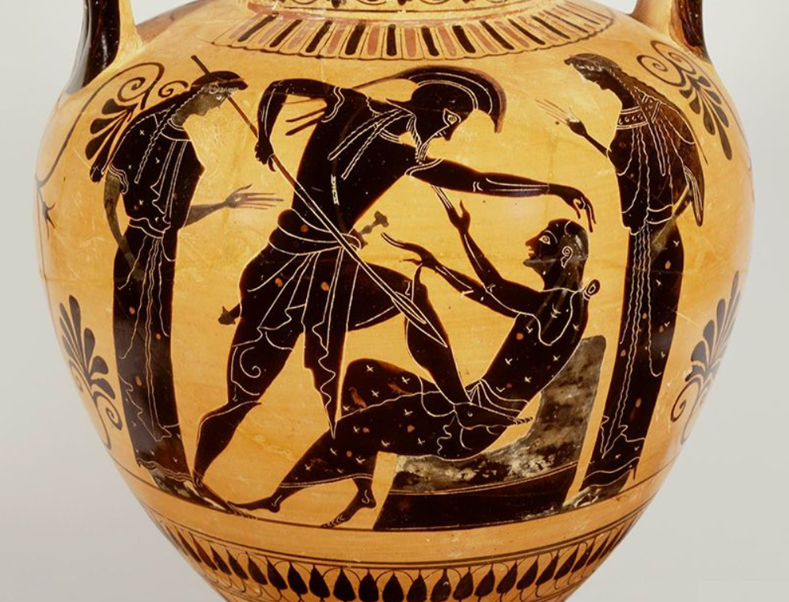
Madeline Miller, author: blog, Monday, February 6th, 2012

It is one of the oldest stories: a famous and powerful man has a son. The son grows up. How will he interact with his father’s reputation? How will he define himself as his own man? It was an even more fraught question in ancient Greece, where no matter how famous a man became, he was called not by his own name, but by his patronymic (his father’s name plus an ending that meant “son of”). So, even though Achilles’ fame far surpassed his father’s, he was still referred to as “Pelides” (son of Peleus). Comparison was inescapable, stitched into one’s identity.

In the stories of the Trojan War, there is a trinity of sons who grow up in the shadow of intimidating paternal legacies: Telemachus, son of Odysseus; Orestes, son of Agamemnon; and Neoptolemus, son of Achilles. All of their stories are worth telling, but I thought I’d start with Neoptolemus (also called Pyrrhus).

One of the strangest things about Neoptolemus is the fact that there seem, in the myths, to be two of him: two mutually exclusive versions of his story, each championed by a master poet, Vergil and Sophocles. In one, Neoptolemus is a sadistic perversion of his father’s legacy, heir to his strength and capacity for violence, but not his humanity; in the other, he is a heroic young man, struggling to do the right thing. Generally, Vergil’s portrait, from book II of the Aeneid, has proved the more lasting, so that is where I will start.

Achilles’ sea-nymph mother, Thetis, desperate to keep her son from an early death at Troy, dressed him as a woman and hid him on the island of Scyros, in the court of King Lycomedes. But Lycomedes’ daughter, Deidameia, discovered the fraud, and she and Achilles conceived a child—Neoptolemus. Shortly thereafter, Achilles was found out, and sailed for Troy, leaving his wife and unborn child behind, for good.

Neoptolemus grew up with a head of red-gold hair, and so earned the nickname Pyrrhus (fiery, the same root as the word pyre). Of his childhood, we know little other than that he was raised on Scyros by his mother and grandfather, with help from Thetis. Like his father, he was named in a prophecy: Troy would never fall unless Pyrrhus came to fight for the Greeks. When his father was killed in the tenth year of the Trojan War, Pyrrhus sailed for Troy. If the timing seems off to you, it is—even if we give Achilles a few years to get to Troy, Pyrrhus should still only be around twelve, absolute maximum.

All I can say is: that is one creepy twelve-year-old. When he gets to Troy, Pyrrhus takes his father’s place as one of the most terrifying and reckless warriors of the Greeks. He is among those in the Trojan Horse, and according to the Odyssey, the only one who isn’t afraid of being caught. Once inside the city of Troy, he uses an ax—Shining style—to tear his way into Priam’s palace, leaving a bloody trail behind him.

One of the things that I love about Vergil as an author is his profound humanism. Even his so-called villains are worthy of sympathy and understanding—all, that is, except for Pyrrhus. With Pyrrhus, Vergil seems to be doing something else entirely: creating a person with no ability to pity or empathize with others. It is, as far as I can tell, the first depiction of a sociopath in Western literature.

Once inside the palace, Pyrrhus chases down the Trojan prince Polites, killing him in front of his father, the aged King Priam, who has taken shelter at the household alters. The old king, in one of the most moving moments in the Aeneid, rises, trembling with grief and age, to deliver a ringing speech that calls down the wrath of the gods upon Pyrrhus for his double blasphemy: killing a son in front of his father, and defiling a sanctuary. As a further reproach, he compares him to his father, unfavorably: “Not even Achilles behaved so to me. He knew how to respect the laws of the suppliant; he returned my son’s body to me, and sent me safely home again.” This is a reference to the famous scene in the Iliad where Priam goes to Achilles’ tent to beg for Hector’s body, and Achilles relents–a shining moment of mercy and hope in an otherwise bloody work.

But you cannot shame a man like Pyrrhus. His response is sneering contempt: “You can go tell my father about my disgraceful deeds yourself. Now, die!”

He seizes the old man by his hair, and drags him, slipping in the blood of his son, to the altar to dispatch him. Later we hear that Priam’s body has been left on the shore, missing its head, for the animals to eat. It is not enough for Pyrrhus to have killed him, he must also dishonor him—mutilating his body and depriving his soul of its eternal peace. The hope kindled in the meeting between Achilles and Priam is snuffed, utterly, by the son.

Sadly, that is only the beginning. After killing Priam, Pyrrhus goes in search of Andromache, Hector’s wife. When he finds her, he seizes from her arms her infant son, Astyanax, and smashes his brains out against the wall. (In fact, in some lurid versions of the story, he uses the baby’s body to club the grandfather Priam before killing him.) Andromache herself he takes captive, as his slave-wife. It is a horrifying cruelty: forcing her to share the bed of the man who murdered her son, and whose father murdered her husband. Then, before returning to Greece, Pyrrhus sacrifices the princess Polyxena on his father’s tomb.

Perhaps it will be no surprise to hear that such a violent man comes to a violent end. Pyrrhus, upon returning to Greece, decides that no bride is worthy of him except for the daughter of Helen herself, Hermione—even though she is already betrothed to Orestes. Rather than wooing her, or trying to negotiate with her father, Pyrrhus presses forward with his usual method: force. He abducts the girl, and rapes her.

One of the things that is most disturbing about Pyrrhus’ story is that his victims are not, as his father’s were, fellow warriors. There is no Memnon here, no Hector, no Penthesilea. Instead we have people who are powerless: infants, the elderly, women not trained in combat. Vergil’s point isn’t, I think, that Pyrrhus is a coward–we see his fearlessness and ferocity in the sack of Troy– but that he’s unnatural. The things which would normally arouse pity in us mean nothing to him. This makes him a very different kind of villain from someone like Agamemnon, whose faults we recognize: selfishness, cowardice, pride, petty brutality. To me, Pyrrhus is a far more frightening figure, a man who is moved by no boundaries or bonds of affection, who acknowledges no limitation on his behavior. The world is made up only of his own strength and everyone else’s weakness.

So who, then, finally stops this unstoppable force? In some versions of the story it takes the god Apollo himself. But in Vergil’s version, it’s Orestes, Agamemnon’s son, enraged at the violence done to his fiance. Pyrrhus has finally crossed the wrong person, and Orestes cuts him down. A satisfying end, and an interesting one too: Agamemnon and Achilles’ feud has repeated itself in the next generation–only this time, at least for me–with the sympathies reversed.

By the way, at Pyrrhus’ death Andromache is freed and, with her brother-in-law Helenus, able to found a new city in Troy’s image, and live out her life in peace.

Notice 480—482: A transition of tone, of place and of point of view. No longer do warriors gaze on warriors, but, passing swiftly from the space immediately inside the doors to the heart of the palace, the narrator is permitted to gaze (through the spyhole) at the women of the palace, and their servants, even if the ‘real’ Aeneas is still located on the roof.
This word even suggests that Aeneas (and not just the poet) witnessed this himself.
Anaphora of PER indicates the many dangers faced by Polites in getting to his father.
Though the verb LUSTRO means here to cross, it also has religious connotations (to purify) and may just possibly indicate that Polites’ death at the altar is seen as a perverted sacrifice.
Enjambment of saucius – highlighted by being only one word in the next line before a new sentence. The surprised when we learn he is WOUNDED: ominous, is it fatal?
Strong word, suggests being literally on fire (with anger). It may also suggest the red-orange pf Pyrrhus’ hair, which is what his name means.
Very compressed phrase, lit. ‘with hostile wound’, meaning Pyrrhus is intending to inflict a deadly wound. Fire in his hair, in his name, in his spirit, in the city. VULNUS, wound essentially means TELUM, weapon.
ENJAMBMENT. Run-on, in keeping with Pyrrhus’ pursuit.
Repetition of iam suggests Polites is ALMOST within his grasp.
CHIASMUS highlights almost catching him by hand and by spear.
Parents comes at the end to highlight the horror of what they should never see, a son dying in front of them.
Hyperbaton of multo. ‘Pouring out’ is vivid. The whole phrase may be an example of ZEUGMA, a verb in two different senses. His blood literally pours out, but his spirit/life ‘pours out’ in a different sense. ‘Life and blood finely interwoven in the word-order too.’ HORSFALL
The sequence of events seems to be pursuit—(any moment now, iam iamque) grasp and fatal thrust—a few more steps (perhaps)—collapse at altar.
Vivid use of TENEO, being held by death, as if Death were a person.
Probably an example of hendiadys = angry voice. (Nothing remarkable stylistically, though it lays stress on the strain Priam feels – presumably his voice is weak and he ought to conserve his energy. Very brave!)
Impassioned anaphora of PRO, in keeping with the excited tone the occasion requires.
What the gods do is dramatically delayed until PERSOLVANT.
The use of qua (ANY) suggests desperation.
Very much a Roman concept, even though Priam is a Trojan. Aeneas will be famous for his pietas.
HORSFALL mentions (I’m not so sure?) “marked spitting alliteration of dentals, tibi, talibus, di, talia.”
Heavily sarcastic and ironic. A “reward” for Pyrrhus should be when the gods PUNISH him.
LETUM is a lofty, archaic word which adds solemnity to Polites’ death, in his father’s eyes.
Alliteration. The verb FOEDO suggests ‘has polluted’ Priam (by the monstrous sight of his dead son):
The baddies is the Aeneid often wish parents to see sons dying! This horror is seen later in Turnus’ evil wish, 10.443 cuperem ipse parens spectator adesset (“I’d would love his father to be here to see <son Pallas, aged 18, dying>.”)
=the famous.
Simply because he does not live up to his father’s standards of magnanimity, Iliad 24.155–8, etc.; Pyrrhus’ additional scorn for the rights of sanctuary will lead to his own death by the altar at Delphi (an end in part the fulfilment of Priam’s curse at 537; see Nicholas Horsfall’s note on 3.332).
The blush of respectful modesty, clearly. (The verb means literally to turn red.)

