Translation document 1
Virgil, Aeneid 2.506 - 525

Fulfilling Dido’s request at the banquet in Carthage, Aeneas begins his sorrowful story of the fall of Troy, adding that retelling it entails re-experiencing the pain. He takes us back to ten years into the Trojan War: at the moment the tale begins, the Danaans (Greeks) have constructed a giant wooden horse with a hollow belly. They secretly hide their best soldiers, fully armed, within the horse, while the rest of the Greek army lies low some distance from Troy. The sight of a massive horse standing before their gates on an apparently deserted battlefield baffles the Trojans.

Near the horse, the Trojans find a Greek youth named Sinon. He explains that the Greeks have wished to flee Troy for some time but were prevented by fierce storms. A prophet told them to sacrifice one of their own, and Sinon was chosen. But Sinon managed to escape during the preparations, and the Greeks left him behind. The Trojans show him pity and ask the meaning of the great horse. Sinon says that it was an offering to the goddess Minerva, who turned against the Greeks after the desecration of one of her temples by Ulysses. Sinon claims that if any harm comes to the wooden statue, Troy will be destroyed by Minerva’s wrath, but if the Trojans install the horse within their city walls, they will rise victorious in war against southern Greece, like a tidal wave, with Minerva on their side.

Aeneas continues his story: after Sinon finishes speaking, two giant serpents rise up from the sea and devour the Trojan priest Laocoön and his two sons as punishment for hurling a spear at the horse. The snakes then slither up to the shrine of Minerva. The Trojans interpret the snakes’ attack as an omen that they must appease Minerva, so they wheel the horse into the city of Troy.

Night falls, and while the city sleeps, Sinon opens the horse’s belly, releasing the Greek warriors. The warriors kill the Trojan guards and open the gates of the city to the rest of their forces. Meanwhile, Hector, the fallen leader of the Trojan army, appears to Aeneas in a dream and informs him that the city has been infiltrated. Climbing to his roof, Aeneas sees fighting everywhere and Troy in flames. He runs for arms and then heads for the heart of the city, joined by a few of his men.

Aeneas and his men surprise and kill many Greeks, but are too badly outnumbered to make a difference. Eventually they go to King Priam’s palace, where a battle is brewing. The Greeks, led by Pyrrhus, break into the palace. Pyrrhus kills Polites, the young son of Priam and Hecuba, and then slaughters Priam on his own altar.

Lines 2.469ff. (David West’s translation)
Aeneas is actually standing on the roof of his own house but acts as an omniscient narrator.
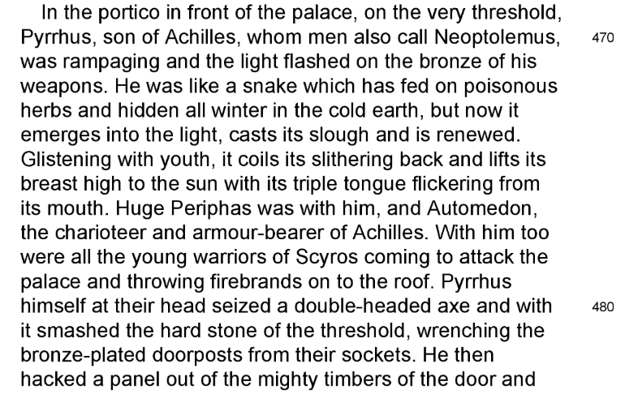

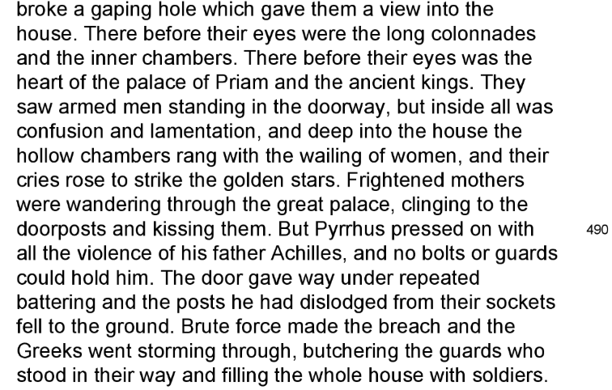

Notice 480—482: A transition of tone, of place and of point of view. No longer do warriors gaze on warriors, but, passing swiftly from the space immediately inside the doors to the heart of the palace, the narrator is permitted to gaze (through the spyhole) at the women of the palace, and their servants, even if the ‘real’ Aeneas is still located on the roof.

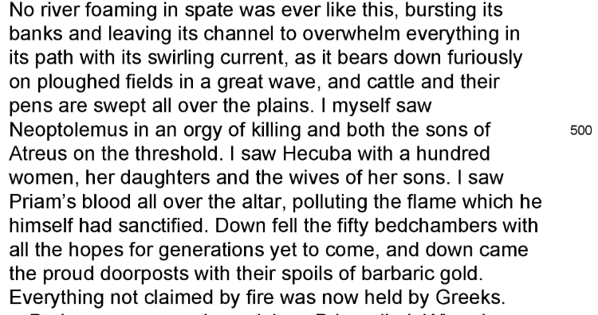

Pyrrhus
Neoptolemus (Classical Greek: Νεοπτόλεμος, Neoptolemos, "new warrior"), also called Pyrrhus (Πύρρος, Pyrrhos, "red", for his red hair), was the son of the warrior Achilles and the princess Deidamia, and also the mythical progenitor of the ruling dynasty of the Molossians of ancient Epirus.

In the lost epic poem Cypria (of which only fragments survive), Achilles sails to Scyros after a failed expedition to Troy, marries princess Deidamia and has Neoptolemus, until Achilles is called to arms again.

In a non-Homeric version of the story, Achilles' mother Thetis foretold many years before Achilles' birth that there would be a great war. She saw that her only son was to die if he fought in the war. She sought a place for him to avoid fighting in the Trojan War, disguising him as a woman in the court of Lycomedes, the king of Scyros. During that time, he had an affair with the princess, Deidamea, who then gave birth to Neoptolemos. Neoptolemos was originally called Pyrrhos, because his father had taken Pyrrha, the female version of that name, while disguised as a woman.

*Greek drama of the 5th century BC shows Neoptolemos as a compassionate young man but Virgil portrays him in a markedly hostile way as brutal. We notice above all Pyrrhus’ ‘failure’ in the Aeneid to treat Priam according to the standards set towards the king by his father Achilles in Iliad 24. {Achilles treats Priam well when he appears in his tent, though he could have slain him on the spot, and returns the body of Hector.}

forsitan et Priami fuerint quae fata requiras. 506

“Perhaps, too, you may inquire what was Priam’s fate.

urbis uti captae casum convulsaque vidit
limina tectorum et medium in penetralibus hostem,

When he saw the fall of the captured city and the doors of his palace shattered/torn off, and the foe in the heart of his home,

arma diu senior desueta trementibus aevo
circumdat nequiquam umeris et inutile ferrum 510
cingitur, ac densos fertur moriturus in hostis.

old as he is, he vainly throws his long-disused armour about his shoulders trembling with old age, girds on his useless sword, and rushes to his death among the thick-packed enemy.

aedibus in mediis nudoque sub aetheris axe
ingens ara fuit iuxtaque veterrima laurus
incumbens arae atque umbra complexa penatis.

In the middle of the palace and beneath the open vault of heaven was a huge altar, and next to it an ancient laurel tree, leaning against the altar and embracing the household gods in its shade.

hic Hecuba et natae nequiquam altaria circum, 515
praecipites atra ceu tempestate columbae,
condensae et divum amplexae simulacra sedebant.

Here, round the shrines, vainly sat Hecuba and her daughters, huddled together like doves swept before a black storm, and clasping the images of the gods.

ipsum autem sumptis Priamum iuvenalibus armis
ut vidit, 'quae mens tam dira, miserrime coniunx,
impulit his cingi telis? aut quo ruis?' inquit. 520

But when she saw that even Priam had taken up the armour of his youth, ‘My poor husband,’ she cried, ‘what dreadful thought has driven you to put on these weapons? Where are you rushing to?

'non tali auxilio nec defensoribus istis
tempus eget; non, si ipse meus nunc adforet Hector.

The time calls not for such aid or such defenders; not even if my own Hector were now here himself!

huc tandem concede; haec ara tuebitur omnis,
aut moriere simul.' sic ore effata recepit
ad sese et sacra longaevum in sede locavit. 525

Come here, please; this altar will guard us all, or you will die with us!’
Thus she spoke, then drew the aged man to her and placed him on the holy seat.
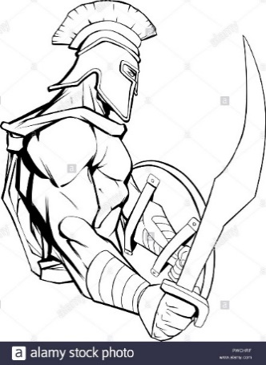

Also called Neoptolemus, son of Achilles
Recent work on the contribution of Pompey’s death to V.’s presentation of Priam’s has led to profitable concentration on Pollio’s account of Pompey’s death (cf. lines 554–8). Note ingens...truncus as an allusion to the cognomen Magnus (557), the image of the headless corpse on the shore, and the actual beheading of the victim (558).
On the fragile presence of Achilles’ son in Homer, and on his status in the Cycle, cf. Edwards on Il.19.326f.. For general discussions, cf. Anderson, 38ff., J. Scherf, NP 8.330–2, O. Touchefeu- Meynier, LIMC 6.1.773–9, EV 4, 121–3, Robert, 2.34, 1218ff., Weizsäcker, Ro.3.167.53ff. and 3360.22ff., K. Ziegler, PW 16.2. 2440.12ff. (optime), von Geisau, ib.24.1.106.42ff.. For his two names, and for V.’s markedly hostile portrait, cf. n. on 3.296. On Pyrrhus’ later years in Epirus, cf. introd. to 2.294–505 and for his death at Delphi, n. on 2.332. {HORSFALL}
An old formula, of anteoccupatio (of the natural question, ‘and how did the king die?’). The speaker ANTICIPATES a question. This shows the close relationship that has been established between Aeneas and Queen Dido of Carthage at the banquet. This also serves as a useful reminder that she is there and being told the story. The breathless alliteration of F in three words in this line might indicate Aeneas’ emotion. The fate of Priam has just been indicated in general terms, but it is natural to ask the particulars of his death. fāta: “the fate,” plural of majesty – it has a majestic sound!.
Notice the harsh alliteration of letter C
The penetrālia of a house were ordinarily entered only by the members of the family. Note then the juxtaposition of contrasts in penetrālibus hostem (Knapp).
In the context this must apply primarily to the main gate or door of the palace, through which Pyrrhus has burst, 491–4. Pyrrhus looked through the breach in the gates, saw Priam, and the guards in the gateway (483–5); Aeneas saw Pyrrhus and the Atridae (=Agamemnon & Menelaus) raging through the palace, saw Hecuba, the Priamidae, and their wives, saw last of all Priam slaughtered at the altar (499, 501). Now Priam himself sees (and we have embarked on third-person narrative) that the gates have collapsed, and in their fall have unleashed Pyrrhus upon the palace within.
Probably a shield (or even breastplate)
Juxtaposition of “long-disused” and “old”.
We know that Priam is about to die; V. now makes quite explicit the futility of his last hopeless, gallant gesture.
Hypallage/ transferred epithet: Priam and not the sword is ‘useless’. But is could also be: because P. is too old to fight, his sword is naturally of no use to him or to the Trojan cause and he will not indeed have time to draw it.
**Notice the accumulation of pathetic detail in these lines. The pitiful details are piled up to show the hopelessness of Priam’s bravery in his helpless age. The juxtaposition of dēsuēta with senior is effective, and senior is deepened by trementibus aevō; the elision with nequiquam suggests his failing strength, and inūtile marks it further; dēnsōs shows the impossible odds against him; moritūrus (here surely of conscious intention, as in 9.400) shows his determination to die a soldier’s death, not as a feeble victim. “It suggests that with his world in ruins, the old king arms himself with the intention of dying in combat.” The terrible picture gains in intensity if we set against it the glowing brutality of Pyrrhus in his prime, as Vergil has shown him in 469 ff. (Roland G. Austin).
nūdō sub aetheris axe: “under the open vault” or “sky” (Frieze); in a Roman house the Penates were kept by the family hearth and altar, in the ātrium, or principal hall, but not in the open air; here, however, is apparently meant a great hall or court, which had a larger opening than the atrium, and contained a garden, or at least a tree or two (G-K). The description is modelled on that of a Roman house, mediā axe, i.e., where the impluvium stood in the centre of the atrium – but remember this is TROY (Howson). Vergil has done more than merely “romanize” the Greek tradition; he has made an essentially domestic picture, and his quiet sanctuary, with its “ancient bay, bending over the altar and enfolding the Penates in its shade,” is in striking contrast to the tumult and desolation all around (Austin). * Just why should this nuditas (bareness of sky) be significant? Not so much the lack of roof, which is to be expected in the impluvium, but perhaps rather a bareness consisting of the absence of potentially kindly moon and stars. Nothing up there to suggest that there might be presences friendly to Troy looking down. (HORSFALL)
veterrima laurus: The aged bay/laurel carries back the mind to the good old times, when all was tranquility and peace (Anthon).
‘embracing’ might suggest the tree can protect them – but not so. It’s a very striking phrase: how do you embrace (literally) with your shade?
just as Priam’s recourse to the sword was of no avail, so here the women take refuge in the sanctity of the altar in vain (Carter); for, in the end, its sacredness failed to save them (Frieze).
The simile is very short, and quite complex. V. has trimmed the detail to a minimum (but might possibly have decided to expand the simile later, if he had lived to finish his work); the doves plunge down (praecipites), as the women rush to the altar; there they huddle (condensae). Doves = innocent; hawks/eagles (not mentioned but presumably chasing them) = evil.
expressive word, “huddled”.
Line 517 has a slow, heavy rhythm. What are these statues? Where are they? What is their relation to the altar? Is the asylum of the altar reinforced by an appeal to the statues of some additional gods? Does V. refer to images of the penates, or of other deities standing in the palace court?
Hecuba begins in mid-verse with direct question and apostrophe; no doubt at all of her intensity and urgency. AUSTIN: Hecuba is not angry with Priam; she means that in this last hour there can be no defence with weapons; she recognizes his brave spirit, but tells him there is no hope except in the gods at the altar.
aut: this usage, found often in early Roman comic poet Plautus (c.200 BC), merely introduces another question not necessarily alternative to the first (Williams).
What is the tone of her speech? Roland G. Austin explains that the tone is tender, not contemptuous; sad that it was necessary for him to do so.
An ellipse of the apodosis: that is to say, we get Hecuba’s “IF” clause, but not her answer. But we can guess it. ‘Not even if my own Hector were now here himself, <could Troy be saved> etc. *Notice that Hector dominates in death as in life.
Meaning his weapons? Or his role as a defender?
hūc concēde or the like is frequent in Roman Comedy when one person asks another to withdraw for a confidential talk i.e. the tone of everyday speech. Vergil has adapted the idiom for his own purpose, making Hecuba speak to Priam just as any ordinary person might speak to another when there is something important to tell him or something urgent for him to do. It is a fine illustration of Vergilian sensitivity to language and tone (Austin). tandem: a word of entreaty or impatience, used here as in questions (G-K) (AG 333a). concēde: observe the double meaning implied in concēde, “come away,” and “give up”. *And ALL IN THREE WORDS! Whew! Holy guacamole!
Tragic irony. We know that the altar will not provide protection, and the mythological ‘fact’ has been heavily reinforced by Virgil’s intimations of the certainty that the Greeks will not respect the sanctuary here sought. Neither altar nor king will provide protection. ‘There is profound tenderness in this scene of Hecuba settling the old king down next to her in an (imagined) place of sanctuary.’ (HORSFALL)

