Separating Salt and Sand
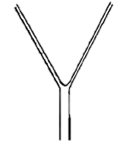
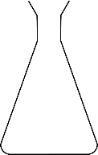
  - Timothy Langer
Sand residue

Salt + water mixture

Filter paper
Filter funnel
Conical flask
Gauze
Tripod
Distilled water
Salt/sand mixture
Beaker
HEAT

Method
We added the salt/sand mixture to water and stirred until all the salt had dissolved; we heated it to speed up the dissolving. We then poured the water/salt mixture and sand into a filter funnel with filter paper and waited until all the water had drained along with the salt. Only sand remained. Our teacher then tested the remaining sand in silver nitrate solution, if it went cloudy, salt still remained in the sand residue.

Results
When tested by the teacher, our silver nitrate solution appeared partially cloudy.

Evaluation
Our experiment was partly successful – the silver nitrate solution did not turn completely cloudy, but only partially in comparison to others’. When stirring to dissolve all salt, we should have stirred more thoroughly in order to completely do so.

