Laboratory preparation of Oxygen Gas
  - Timothy Langer 4E
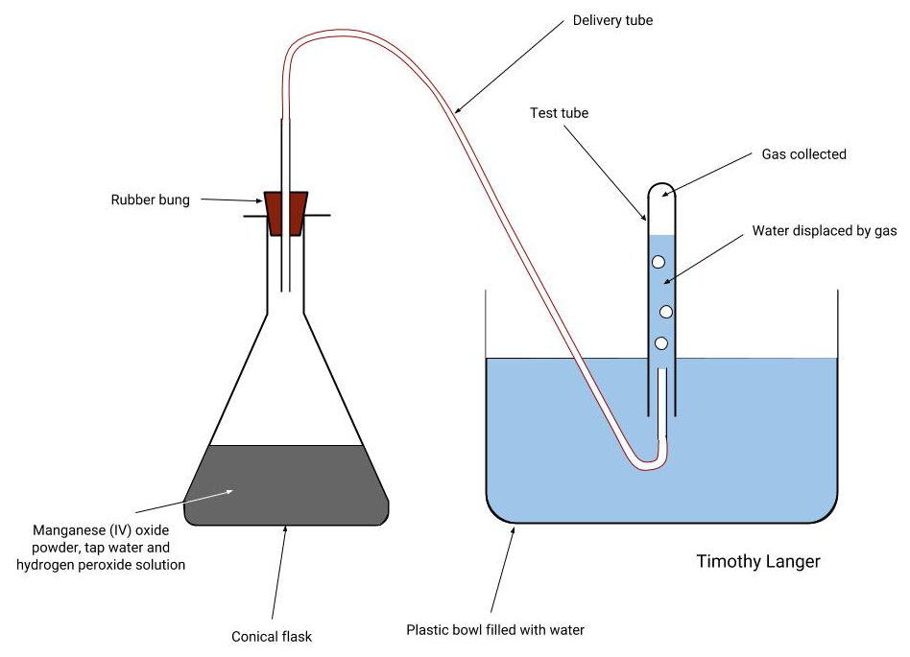

Observations
Once manganese (IV) oxide was added to the hydrogen peroxide, the clear solution turned dark due to the powder added and started producing bubbles. The gas produced travelled through the delivery tube and displaced water in the test tube, bubbles could be seen emerging from the end of the delivery tube.

Questions
- A catalyst speeds up chemical reaction without being used up. How could you show that the manganese (IV) oxide here was not used up?

The substance in the conical flask stayed dark even after the reaction stopped, so we can show that the manganese (IV) oxide, which turned the substance dark in the first place, was still in the flask.

- Is this a method which would be suitable for making large amounts of oxygen, for use in hospitals or the steel industry? Explain your answer and suggest another way by which industrial amounts of oxygen may be obtained.

Our method produced roughly three test tubes of oxygen from 25cm³ hydrogen peroxide. This is a very small amount, which is why to produce industrial amounts of oxygen it is preferable to use fractional distillation in order to collect oxygen from the air, since air is free and there is air all around us.

PTO

Testing for Oxygen Gas
Once a suitable amount of gas had been collected in the test tube, a rubber bung was inserted into the test tube to keep the oxygen gas inside. Later, the teacher tested for the presence of oxygen in the test tube by thrusting in a glowing splint. In our test tubes, the splint glowed more brightly but did not relight.

